
Tech Academia Portfolio Template

Please use this template to upload your business challenges. You can use the following format

Change the title of this document to your name and add your business challenges in the following format.

Business Challenge
- Image of your project
- Your tech stack
- Link to your product development report
- Link to your github repo

Example: PACS-EMR Integrated web application ( Patient Data Management System Challenge)
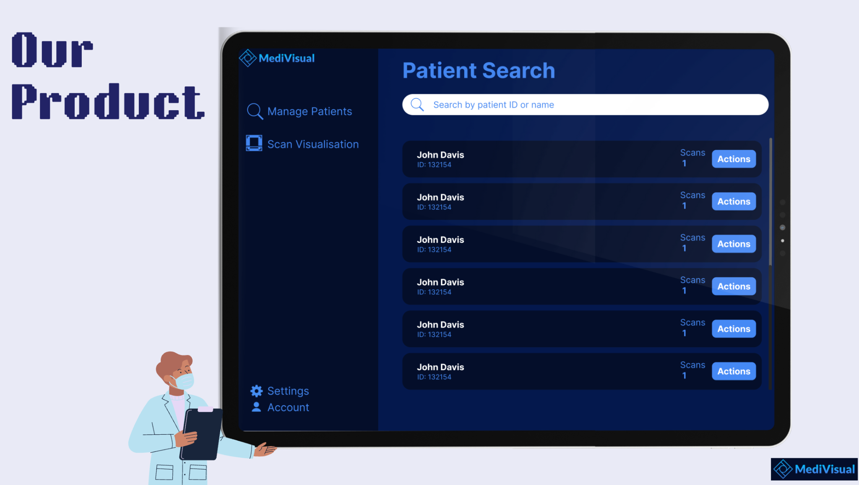
Tech Stack
- Backend: Python, FastAPI
- Database : MongoDB
- Frontend: React JS, Tailwind CSS, Axios
Product Development report: (Link your product development report here)
Github: (Link your github repo here)

